**Handy Travel Application Development Project**

**Personal Evaluation of the Handy Travel App Development Initiative:**

The Handy Travel Application Building Project is a challenging and comprehensive project that needs to be carefully planned, carried out, and monitored in order to succeed. Handy Travel Co. Ltd. could gain a competitive edge, higher satisfaction with clients, and revenue generating from the initiative, among other important advantages. The goal of Handy trip Co. Ltd.'s strategic project, the Handy Travel Application Development Project, is to launch a feature-rich mobile application that makes trip planning and booking easier.

The project aims to earn income through several channels, with an emphasis on providing a smooth and user-centric application. Six months is the allotted time to complete the project. The initiative is not without danger, though, and some of these include user uptake, market competition, and technological difficulties. In this assignment I assume to be the upcoming manager to the project while responding to the prompts provided.

**An explanation of estimation techniques, as well as tools and methods for controlling the budget and schedule**

Estimation Techniques: ascertain the length of each task, the project will make use of a variety of estimation techniques, such as:

* Expert Judgment: When estimating time, project team members with relevant experience are consulted for their expertise. When evaluating project timelines and resource requirements, expert opinion is essential. Utilizing the experience and knowledge of project team members who have relevant work experience allows us to obtain important information that guides our planning and decision-making procedures. Within the Handy Travel Application Development Project, the following team members' experience might be put to use:
* Development of the Project: we can utilize the expertise of the following team members:
  1. David E., Project Manager: David can offer general direction on project schedules and resource allocation because of his vast expertise overseeing software development projects.
  2. Ellis C., Business Analyst: Ellis's thorough comprehension of the target audience and business needs can help estimate the amount of time needed for planning and analysis tasks.
  3. Noah S., UI/UX Designer: Noah's knowledge in user experience design can be used to gauge how long design and UX tasks will take.
  4. Kenneth K., Frontend Developer: Kenneth's knowledge of frontend development can help determine how much time is needed for coding and development tasks.
  5. Selina W., Backend Developer: Selina's knowledge of backend development can be useful in determining how long development and coding tasks will take.
  6. Jennie A., QA/Test Engineer: Jennie's knowledge of quality control can help with estimating the amount of time needed for bug fixes and testing.
  7. Mark. F., Mobile App Developer: Mark's knowledge of creating mobile apps can be used to gauge how long the coding and development will take.
  8. Jackie C, a marketing specialist, can provide insight into the time needed for app store submission and launch activities based on her background in marketing and advertising.
  9. Harry O., Project Officer (All-Round): Harry's adaptability and background in a range of project areas can help with estimation.
* Parametric Estimation: Employing historical data or industry benchmarks to estimate activity durations based on comparable projects.
* Three-Point Estimation: This method increases the precision of project duration estimates by accounting for a range of potential outcomes. Three estimates are collected for each action: a most probable projection that represents the most plausible course of incidents, a pessimistic estimate that represents the worst-case scenario, and a hopeful estimate that represents the best-case scenario. These estimates are then aggregated using the weighted average method, which assigns greater weight to the estimate that is more likely to be correct. By taking into consideration probable uncertainties and unforeseen challenges, this technique offers a more thorough and accurate assessment of project timescales. It supports project managers in their decision-making, efficient resource allocation, and risk mitigation.

**Tools and Techniques for Managing Schedule/Budget**

The project will make use of a number of instruments and methods to efficiently oversee the budget and timeline:

* Gantt charts: Using bar charts that show the beginning and ending dates of each task, you can visualize the project schedule and spot possible bottlenecks.
* The Critical route Method (CPM) involves examining the project network to identify the critical route, or the order of tasks that need to be finished on time in order to guarantee the project's overall schedule.
* Earned Value Management (EVM): Comparing the estimated value of work to the actual value of work performed allows for the tracking of project progress and the early detection of any problems.

**An Overview of the Budget and Schedule Process**

The schedule and budget will be developed iteratively, providing for flexibility and adaptability to changes in the needs or scope of the project. This process includes:

* First Planning: Creating a baseline budget and plan using the information and assumptions that are already available.
* Regular Review and Updates: As the project moves forward, review the budget and schedule often, adding new details as needed, and modifying the plans as necessary.
* Change Management: Putting in place a structured procedure for managing changes to the scope, budget, or schedule in order to evaluate and approve them.

**Network Diagram using Critical Path Method**

The project's workflow is mapped out in the Network Diagram, which also shows the relationships between tasks and their corresponding durations. Project managers can understand the project's structure and spot any interconnections or bottlenecks that can affect the timeline's total duration thanks to this visual representation.

When CPM is integrated to the Network Diagram, the beginning and latest start and end times for every activity are determined. The critical path—the order of tasks that must be finished on time in order to guarantee the undertaking's timely completion—is highlighted in this study. By determining the key path, project managers can reduce the likelihood of delays by concentrating their time and efforts on these essential tasks.

Table 1: Network diagram and CPM table data

|  |  |  |
| --- | --- | --- |
| Activity | Duration(days) | Predecessor(s) |
| Project initiation | 3 | - |
| Analysis and planning | 15 | Project initiation |
| Design and user experience | 30 | Analysis and planning |
| Development / Coding | 65 | Design and user experience |
| App store submission and launch | 48 | Development / Coding |
| Post-launch and maintenance | 18 | App store submission and launch |

**Project Schedule**

A project schedule is a flowchart that shows the beginning and ending dates of every task in the project. It is an essential tool for efficiently organizing, planning, and carrying out undertakings. A clear project timeline facilitates:

* Visualize the status of your project: By monitoring each task's advancement, project managers can spot possible hold-ups or bottlenecks early on.
* Share expectations: The project schedule informs stakeholders of the anticipated timeframe for project completion and acts as an avenue for interaction.
* Organize resources: The project schedule aids in organizing the distribution of resources, guaranteeing that the appropriate personnel and tools are accessible when needed.

Below is a tabular representation of the project schedule:

Table 2: Project Schedule

|  |  |  |
| --- | --- | --- |
| Activity | Start Date | End Date |
| 1. Project initiation | 2023-12-01 | 2023-12-03 |
| 2. Analysis and planning | 2023-12-04 | 2023-12-18 |
| 3. Design and user experience | 2023-12-19 | 2024-01-27 |
| 4. Development / Coding | 2024-01-28 | 2024-03-10 |
| 5. App store submission and launch | 2024-03-11 | 2024-04-14 |
| 6.Post-launch and maintenance | 2024-04-15 | 2024-04-30 |

**Ghant chart**

The image below is a representation of the ghant chart based on the activities:

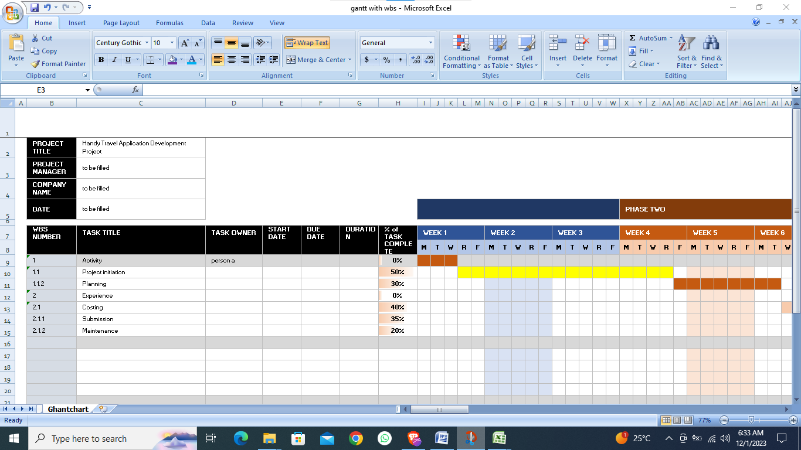

Figure 1:Ghant chart

**Cost Baseline**

An extensive summary of the projected expenses for every project activity is called a cost baseline. It acts as a point of comparison for monitoring project costs and spotting possible overruns. A thorough cost baseline is beneficial for:

* Calculating project costs: By giving decision-makers a reasonable idea of the project's overall cost, the cost baseline facilitates informed decision-making.
* Managing project costs: To find and fix any cost variations, project managers can keep an eye on actual costs in comparison to the cost baseline.
* Effective resource management is ensured by following the cost baseline, which directs resource allocation.

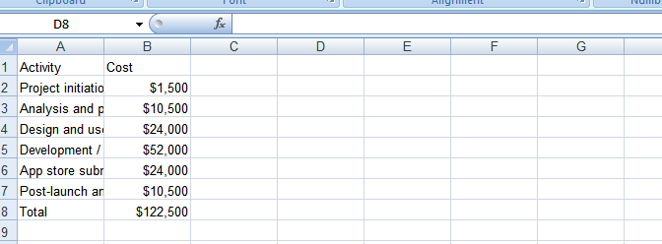

Figure 2: Cost Baseline

**Project Cost Estimate (Budget)**

An approval to spend money on a project is contained in a project budget. It acts as a control tool for project expenses and lists the authorized financial resources for every activity. An organized project budget facilitates:

* Manage project spending: By putting restrictions on project expenses, the project budget helps to avoid overspending.
* Set project activity priorities: distributing resources and deciding are guided by the budget's reflection of each activity's importance.
* Monitor financial performance: To evaluate financial performance and spot possible problems, project managers might compare actual spending to the budget.

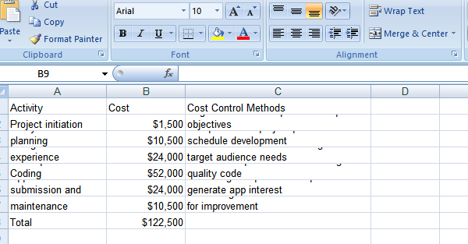

Figure 3: Cost estimate(budget)

References

Kim, J., Kang, C., & Hwang, I. (2012). A practical approach to project scheduling: Considering the potential quality loss cost in the time–cost tradeoff problem. *International Journal of Project Management*, *30*(2), 264-272. <https://doi.org/10.1016/j.ijproman.2011.05.004>

Vanhoucke, M. (2013). The PERT/CPM technique. *Project Management with Dynamic Scheduling*, 11-35. <https://doi.org/10.1007/978-3-642-40438-2_2>